**Practical No. 3**

**Aim:** Create Restful services from pattern

**Steps:**

Step 1: Create a new web application

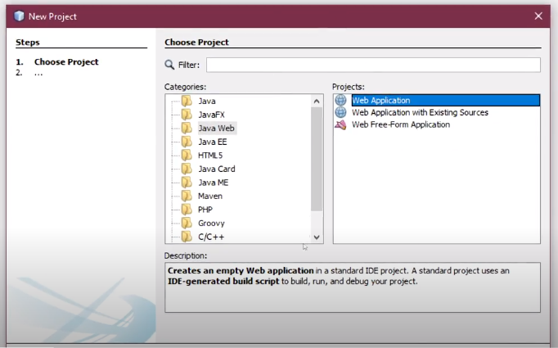

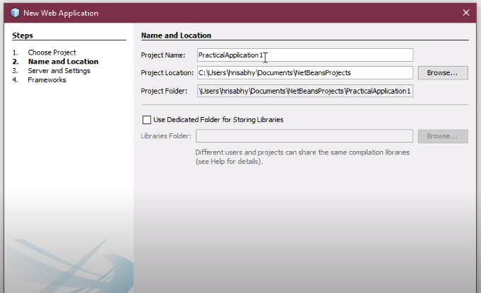

Step 2: Right click on the web application/project select New then give the project and resource package a name, set MIME type to text/html then click on finish.

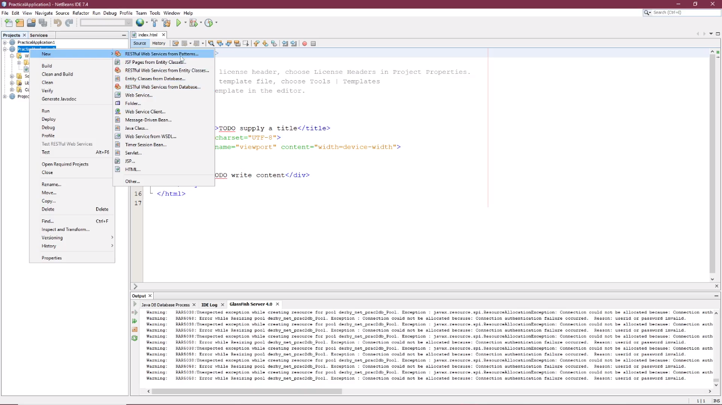

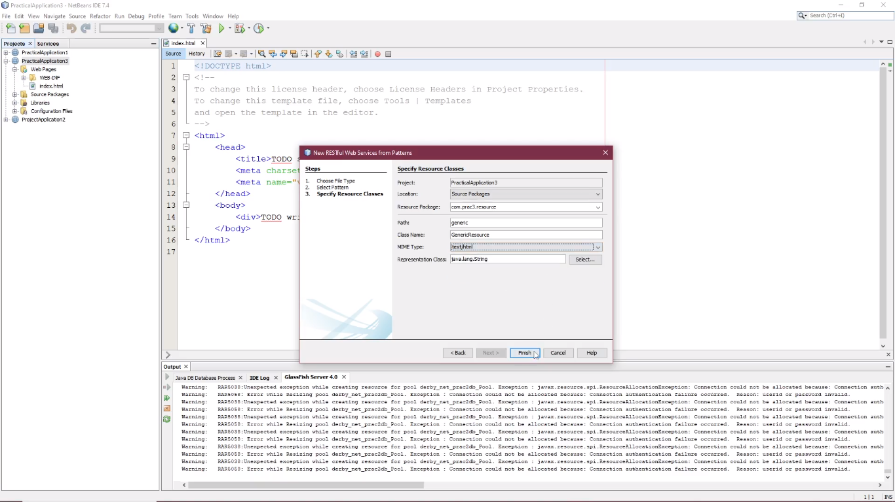

Step 3: In genericResources.java under getHtml () remove the exception line and add the following line.

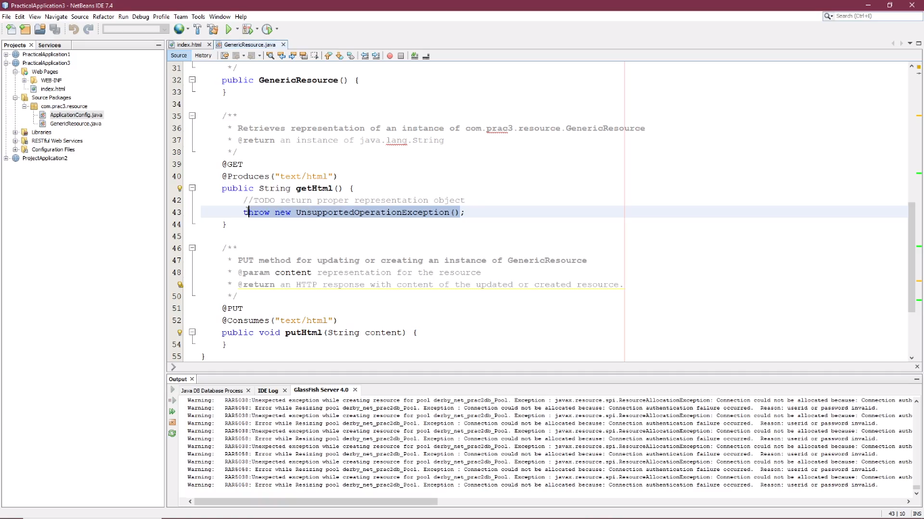

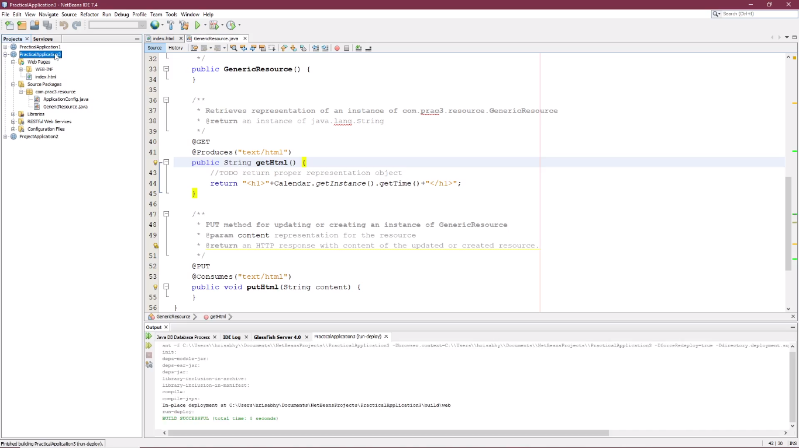

Step 4: Right click on the project and click on Build and after a successful build click on Deploy.

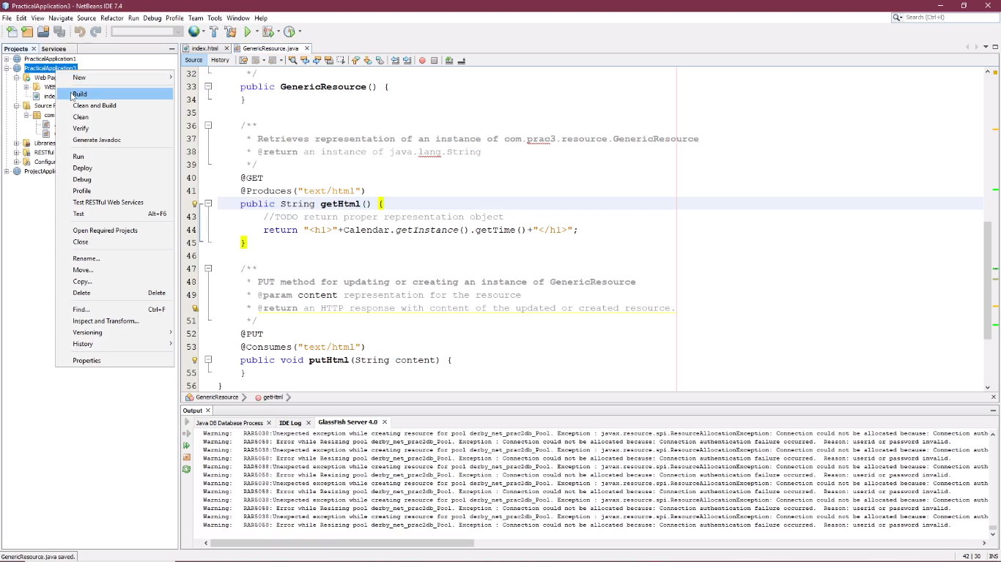

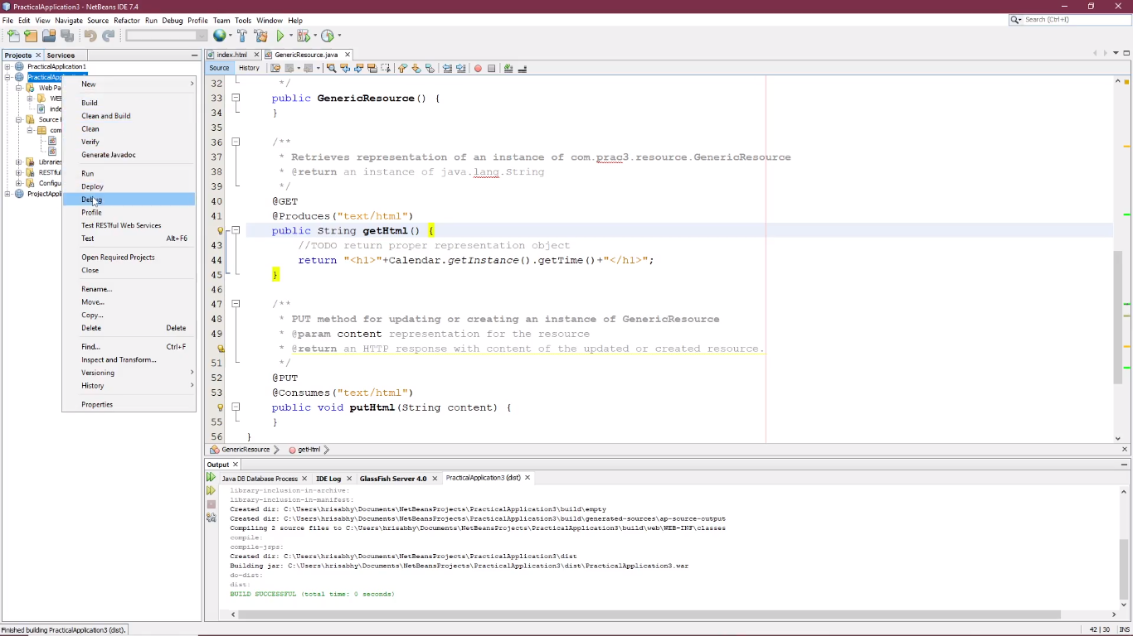

Step 5: Under Restful services -> GenericResources -> HTTP Methods -> right click on getHtml().string and click on Test Resources

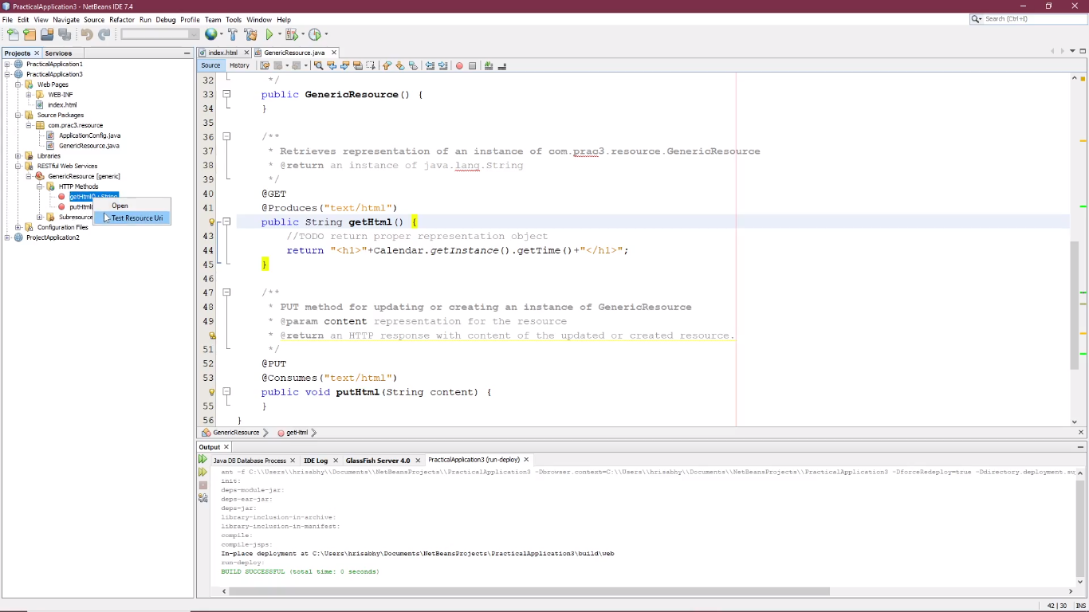

Output:

